DAILY MATH REVIEW 2 (7th Grade)

Name____________________________________Date__________________________________
Mon. | 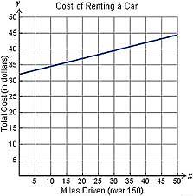  Mark says the relationship is proportional because you always pay $1 for every 4 miles you drive. Nina disagrees and says that the relationship is not proportional because you first have to pay a $32 gas tank fee. Who do you agree with, and why? | In 2002, the price of a gallon of gas was $1.56. One year later, the price rose to $3.29. What was the percent increase from 2002 to 2003? | Chase spent $4.35 for 2.5 pounds of Granny Smith apples. At this rate, how much would he spend for 6 pounds of apples?  What would be the cost for one pound of apples? What does this rate represent?
Tues. | Cost ($) 10 17 24 31  #of Tickets 1 2 3 4  The table below shows the cost for ordering x number of tickets for a Belmont men’s basketball game.  Is the relationship between cost and the number of tickets proportional or nonproportional? Explain. | Clothes Are Us and Radcliff’s are having holiday sales. At Clothes Are Us, a sweatshirt is on sale for 40% off the regular price of $50. At Radcliff’s, the same sweatshirt is discounted by 30% off of the regular price of $40. Which store has the better sale price? Explain. | Simplify the following expression  (3x – 10) + (2x + 5)
Wed. | 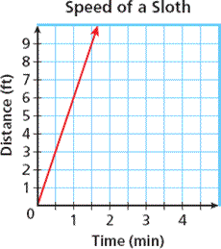  What does the point (1.5, 9) represent?  How many feet could this sloth travel in 4 minutes?  How many feet could this sloth travel in 4 minutes?  What is the constant rate of change? | Alexander bought a Macbook Pro laptop last weekend. Since he is a teacher, he gets a 15% discount off any purchase he makes from the Apple Store. The laptop was listed at $1,200. How much did Alexander pay if he got the 15% discount and also paid 9.25% sales tax? | Simplify the following expression.  (-4x + 1) – (8x – 3)
Thurs. | The table below shows the distance traveled by an iguana for x amount of minutes.  Hours (x) 10 20 30 40  Miles (y) 20 40 60 80  Graph the data on the coordinate plane below.  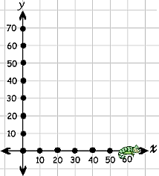  Is the relationship between the iguana’s time and distance proportional or non-proportional? Explain in the space below. | In preparation for the upcoming holiday season, Macy’s department store has decided to offer a 20% discount on all winter coats. What would be the sale price of a coat that was originally $450 with a 9.25% Tennessee state sales tax? | Tia is painting her house. She paints $34\frac{1}{2}$ feet in $\frac{3}{4}$ hour. At this rate, how many square feet can she paint each hour?
Fri.

Daily Math review Expectations
- Complete all problems each day.
- Do your original work using a pencil at the beginning of class.
- Make corrections using a pen, colored pencil, or marker during our whole class discussion.
- If you are absent, you are still responsible for completing all of the problems.
- Turn this in each Friday for a grade out of 15 points for accuracy.
Grade:__________/15

